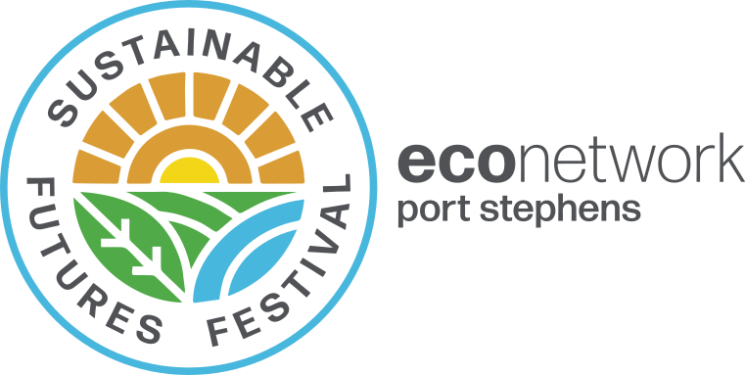
Business and Stallholder
expression of interest

Expression of interest to participate in the
Sustainable Futures Festival
At St Philip's Christian College on Sunday 11th September 2022
Name: ABN:
Address:
Contact person & position:
Mobile: Email:
Please describe your product / service and how it reflects the theme of sustainability.

Tell us how you would like to be involved: (tick as many as applicable)
[ ] Sell a product
[ ] Have a display marquee
[ ] Sponsor a speaker or event — Sponsor packages can be designed to suit your needs
[ ] Involve children/families in activities
[ ] Sell food
[ ] Tent Talks —scheduled on Festival program in addition to main stage speakers.
Other:

Indicative stallholder or marquee* site  where not part of sponsorship package | Cost | Scheduled Program Tent Talks
Large business / corporate | $150 | $50
Government funded NGO | $100 | $40
Food businesses: meals, coffee vans etc. consume at festival | $80
Small / medium businesses | $60 | $25
Community group / Not for profits | $40 | $15
Individual / student | $20 / $10 | $5
EcoNetwork members 50% discount Membership https://www.econetworkps.org/join-us/
* All stallholders supply own marquee and power. Space generally enables a 3mx3m marquee. Larger marquees may attract a higher site cost.

Return this form to SFFstalls@econetworkps.org and a committee member will contact to discuss.

General and sponsor enquiries, please email festival@econetworkps.org

